Assignment-1
Domain: IOT
TOPIC: SMART HOME
NAME:KARTHIKA M
REG.NUMBER:952819106013
COLLEGE: SCAD COLLEGE OF ENGINEERING AND TECHNOLOGY
Smart Home:
Circuit:

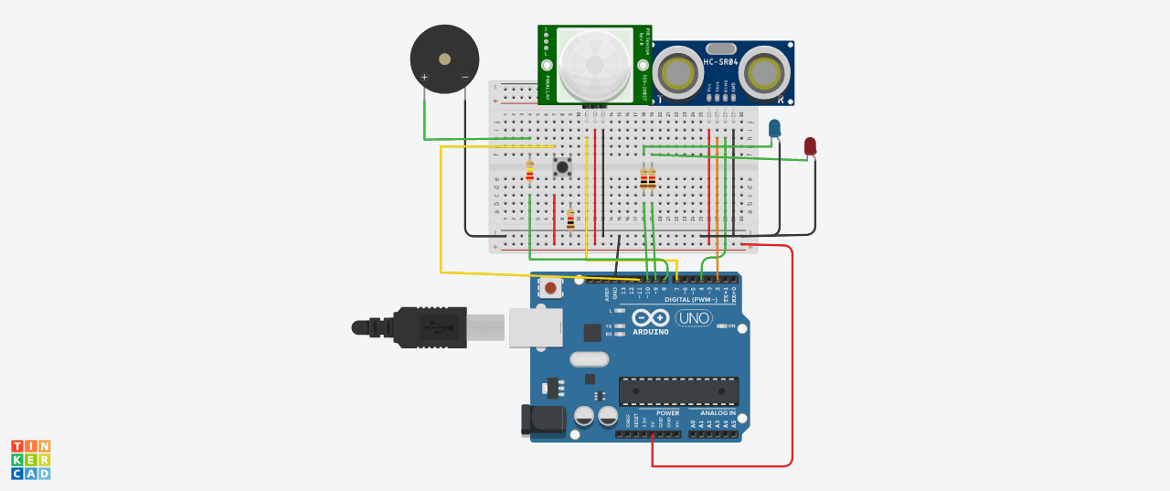

Components:
Quantity | Components
1 | Push Button
1 | Red LED
1 | Blue LED
1 | PIEZO Buzzer
1 | Ultrasonic Distance Sensor
2 | PIR Sensor
2 | Resistor (220,560,10K)
1 | Arduino R3
1 | Breadboard Small

Code:
const int trigPin = 2; //the trig pin of the ultrasonic sensor; sends signal
const int echoPin = 4; //the echo pin of the ultrasonic sensor; detects signal

const int pirPin = 7; //the PIR sensor pin
int pirState = LOW; //basically means that the PIR sensor starts as low and detects no motion

const int buzzerPin = 8; //the buzzer has been connected to pin 8

const int redLED = 9; //the red LED; intensity can be controlled to change the colour emitted
int redBright = 0; // how bright the LED is
int redFade = 5; // how many points to fade the LED by

const int greenLED = 10; //the green LED; intensity can be controlled to change the colour emitted
int greenBright = 0; // how bright the LED is
int greenFade = 5; // how many points to fade the LED by

const int button = 13; //button to momentarily reset all the sensors back to normal

void setup() {

pinMode(echoPin, INPUT);
pinMode(pirPin, INPUT);
pinMode(button, INPUT);

pinMode(trigPin, OUTPUT);
pinMode(redLED, OUTPUT);
pinMode(greenLED, OUTPUT);
pinMode(buzzerPin, OUTPUT);

Serial.begin(9600); // initialize serial communication at 9600 bits per second
}

void distance() {

long durationInDigit;
long distanceInInches;

digitalWrite (trigPin, LOW); //set this to LOW to start with
delayMicroseconds(2); //delay in microseconds between different commands
digitalWrite (trigPin, HIGH); //here, the trig pin sends signals or vibrations to be detected
delayMicroseconds(10);
digitalWrite (trigPin, LOW); //set the the trig pin back to low

durationInDigit = pulseIn(echoPin, HIGH);
distanceInInches = durationInDigit/74/2;

Serial.println(distanceInInches);

if (distanceInInches > 15 && distanceInInches < 30) {
digitalWrite(greenLED, HIGH);
digitalWrite(redLED, LOW);
}

if (distanceInInches < 10) {
digitalWrite(redLED, HIGH);
digitalWrite(greenLED, LOW);
}

if (distanceInInches > 10 && distanceInInches < 15){
digitalWrite(redLED, LOW);
digitalWrite(greenLED, LOW);
}

if (distanceInInches < 5) {
digitalWrite(redLED, HIGH);
tone(8, 250, 2000);
digitalWrite(greenLED, 0);
}

if (distanceInInches > 5 && distanceInInches < 10){
digitalWrite(redLED, HIGH);
digitalWrite(buzzerPin, 0);
digitalWrite(greenLED, 0);
}

if (distanceInInches > 30 || distanceInInches < 0){
Serial.println("Distance Incalculable");
}

delay(500);

}

void reset() {
if (digitalRead(button), HIGH);
digitalWrite(pirState, LOW);
digitalWrite(redLED, LOW);
digitalWrite(greenLED, HIGH);
digitalWrite(buzzerPin, 0);
//digitalWrite(echoPin, 0);
}

void loop() {

distance();

int pirState = digitalRead(pirPin);

if (pirState==1) {
Serial.println("Motion Detected!!!");
digitalWrite(greenLED, LOW);
digitalWrite(redLED, HIGH);
digitalWrite(buzzerPin, 1);
delay(500);
}

if (pirState==0) {
Serial.println("Detecting...");
digitalWrite(greenLED, HIGH);
digitalWrite(redLED, LOW);
digitalWrite(buzzerPin, 0);
delay(500);
}

}

